Feature image: "Get certified today – no experience needed!"



Title: How to Get an Esthetician Certification with No Experience
Focus Keyword:Esthetician Certification
Secondary Keyword:
esthetician school houston tx
top esthetician schools in houston

Internal links
licensed esthetician: https://imageacademy.org/esthetician/
cosmetology school houston: https://imageacademy.org/

Meta Description:
Get your esthetician certification at Image Academy in Houston. No experience needed - our program guides you from enrollment to licensing and career success.

How to Get an Esthetician Certification with No Experience H1

Does your interest lie in the skincare industry? Do you need a bright future in the fastest-growing area of esthetics? If so, then you should consider becoming a certified esthetician because it is a very rewarding experience.
Established in the lively city of Houston, Texas, Image Academy is designed to provide guidance to help students earn the esthetician certification even if they are coming in with no background in this field.
In this blog, we shall discuss step by step how to go through the process of selecting the best school for esthetician training in Houston to the experience and knowledge that is needed to make one a practicing esthetician.

Step 1: Understand the Role of an Esthetician H2
Let us start by analyzing the background of estheticians before covering the process which will lead to certification. Estheticians are skin care professionals who give attention to balancing, upgrading and maintaining the skin’s health of clients. They do massages for the face, shaving, and giving advice on skin care. The position of an esthetician is quite popular nowadays due to the development of beauty related sectors and services.

Step 2: Do Research on Available Esthetician Schools H2
In this step, you need to find out the top esthetician schools in Houston that are near you.
The selection of an ideal esthetician school Houston TX is very crucial in your course. There are many esthetician schools in Houston, Texas, specifically, Image Academy is one of the best schools that offers extensive courses and courses offered by professional tutors. Here are some steps of how to get to find the best school to take an esthetician course in Houston.

Accreditation H3
The school should always be accredited and this accreditation should be from the office of the Texas Department of Licensing and Regulation (TDLR). An Accreditation school ensures that the education the students get is one that is recognized by the industry.

Curriculum H3
Ensure that it has nearly offered all major areas of training such as body structure, skin physiology, cleansing, and entrepreneurship. A comprehensive course therefore trains students for all domains of esthetician practice.

Practical Training H3
Physically engaging exercises require higher engagement, and there is no comparison between hands-on training and any other forms of training. Select a school that provides many opportunities for practical training and stepping into the positioning under the direction of tutors.

Available Facilities H3
Here, it is recommended to see the campus and check the availability of the facilities personally. Modern and equipped labs and class rooms facilitate you and other students to get more out of what is taught in the class.

Reputation H3
Besides, it is paramount to assess the school’s reputation by talking to former students and reading online reviews. An accredited school can provide a ticket to employment and contact details of other employment sectors.

Here at Image Academy, you get to enjoy everything related to esthetician. We are among the best esthetician schools in Houston in terms of curriculum, expertise as well and learning environment.

Step 3: Enroll in a Cosmetology Program H2
After deciding on the school, it is then the rightful time to enroll yourself in a cosmetology program. Here’s what you can expect:

Duration H3
Varying from state to state, most esthetician programs in Houston take approximately from 600 to 1000 hours of course.

Hand-on Knowledge H3
Facials course provides knowledge about skin facial structure and its types, different types of skincare products, facial massages and selected treatments of the skin disorders. Business practices and safety regulations will also come into your learning topic.

Future Exam Preparation H3
It will prepare you for the State Board Licensing Exam that is required if you want to become a Texas state-licensed esthetician.

Attending a cosmetology school in Houston also assures you of getting all the required knowledge that puts you in a good position to work in esthetics.

Step 4: Gain Practical Experience H2
Having gone through this long and powerful argument on why people should enroll in formal education, it is important to state that practical experience is just as significant in life. Here are a few ways through which one can acquire this hands-on practical experience during your studies:

Internships H3
A number of schools provide the experience of internships where agreeably you can work among real estheticians in real salons or spas. Such experiences enable you to practice what has been taught in a real life atmosphere.

Workshops H3
An effective way of practicing arts is through clinics and workshops that are taught by individuals from your school. These are extra and homogeneous with the tasks and issues that help to enhance the skills of the students.

By studying at Image Academy you will have a lot of chances to get some practice thanks to our cooperation with local salons and spas.

Step 5: Prepare for the Licensing Exam H2
If you want to become a licensed esthetician in Texas, you will have to take the State Board Licensing Exam after the completion of your program. Here’s how you can prepare for your licensing exam:

Classroom Learning Resources H3
Go through the relevant textbooks, online resources and other good quality study material that your school provides. It’s always advisable to prepare before you take any exam. Image Academy will provide you with a detailed session about the licensing exam so you can clear it with ease.

Sample Papers H3
Solve sample papers so that you get accustomed to the questions which are asked in the actual examination.

Study Groups H3
You can join study groups from fellow colleagues to cover the material together. It is beneficial to discuss ideas and solve problems to improve the knowledge of the people involved.

Mock Exams H3
Another aspect students should take advantage of is the mock exams that are provided by the school to provide an idea about the examination environment and conditions.

Step 6: Apply for Licensure H2
In the process of licensing, you will need to apply for a license after passing your licensing exam. Here is one of the simplest processes you need to follow;

Application H3
Submit your application to the Texas Department of Licensing and Regulation (TDLR), along with other required documents and fees.

Background Check H3
As for one of the steps necessary to complete in order to get a job with the company, you will have to pass a background check.

Get Your License Finally, upon passing the test, you will be issued with a licensed esthetician certificate which permits you to practice in the field.

Step 7: Start Your Career H2
Once you have obtained your certification, it is time to start your esthetician job. Here are the following tips that will surely help you to succeed:

Create a Portfolio H3
Develop a portfolio containing details about your abilities, and the treatments and results of the clients. This will help you to get the attraction of clients and other employers in the market.

Networking H3
This is a common approach that you are encouraged to undertake with the aim of getting a job at salons, spas or skin clinics. With the help of networking, you can easily come across jobs that are available in the market.

Keep Learning H3
The beauty industry is always changing. Therefore, more advanced courses can be offered in workshops, seminars, and educational classes to enable you to get the latest knowledge.

Build a Customer Base H3
Special offers, discounts or free advisory services can be used in an attempt to attract potential clients. Clients are an essential aspect when it comes to estheticians. So, you need to make sure your clients remain loyal.

Final Thoughts H3
It is very possible to get a job as an esthetician with no experience by going for the correct education, practicing, and being very determined to do the course. We are here at Image Academy in Houston, TX and dedicated to assisting you in fulfilling your goal of being an esthetician. Due to our comprehensive packages, along with the well-experienced faculties and our learning-friendly atmosphere, we are counted as one of the best esthetician schools in Houston.

Start your journey towards your successful career in esthetics by joining an esthetics program at Image Academy. Welcome to a path that will create the foundation of an experienced and competent esthetician.
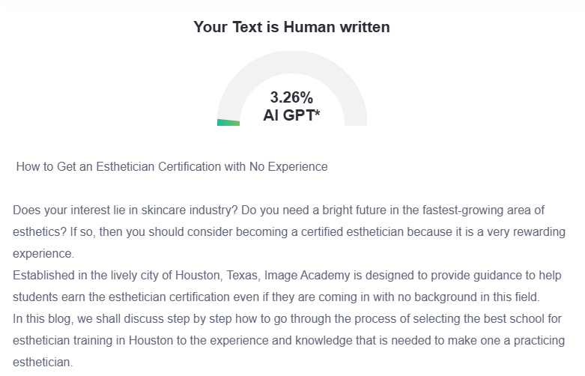

GMB
Looking to break into the skincare industry without prior experience? At Image Academy in Houston, we've helped countless students achieve their esthetician certification from scratch. The journey begins with understanding what estheticians actually do: they're skincare specialists who perform facials, waxing, and provide expert skin advice in a booming beauty sector. The selection of the right beauty institution proves an essential decision. Go for a school that has TDLR accreditation combined with ties to an extensive skin physiology curriculum and pragmatic business training combined with numerous practical exercises. Our school provides classroom training alongside experiential learning opportunities which are made possible through connections with neighboring beauty service providers. We equip you with complete study materials along with numerous practice tests combined with mock examinations for your best performance on the licensing exam day. Once you successfully complete your exam you need to apply to the TDLR for license issuance and pass a background test before getting your license. Multiple opportunities await you in your professional path after your license is granted. At Image Academy, we're committed to supporting you through every step of your esthetician journey. Our experienced faculty and supportive environment make us one of Houston's top esthetician schools. Ready to start your new career path in skincare? Join us at Image Academy today!

